Project Planning Phase
Project Planning Template (Product Backlog, Sprint Planning, Stories, Story points)
Date | 01 October 2026
Team ID | 6ab6292ddcdae33acb3906da
Project Name | Import Data Using Transform Maps (Spreadsheet)
Maximum Marks | 5 Marks
Product Backlog, Sprint Schedule, and Estimation (4 Marks)
Product backlog and sprint schedule for the Import Data Using Transform Maps project. Each sprint holds 20 story points.
Sprint | Functional Requirement (Epic) | User Story Number | User Story / Task | Story Points | Priority | Team Members
Sprint-1 | Table creation | USN-1 | As an administrator, I can create the Employee Training Records table with the fields Training Name, Completion Date, Status and Employee (reference to sys_user). | 5 | High
Sprint-1 |  | USN-2 | As an administrator, I can add choice values (In Progress, Completed) to the Status field. | 2 | Medium
Sprint-1 | Data import | USN-3 | As an administrator, I can prepare an .xlsx file with Training Name, Completion Date, Status and Employee columns. | 3 | High
Sprint-1 |  | USN-4 | As an administrator, I can upload the file using Load Data to create the import set table u_employee_training. | 5 | High
Sprint-1 | Transform map | USN-5 | As an administrator, I can create a transform map from the import set table to the Employee Training Records table. | 5 | High
Sprint-2 |  | USN-6 | As an administrator, I can add field maps for training name, completion date, status and employee. | 3 | High
Sprint-2 |  | USN-7 | As an administrator, I can run the transform to move staged rows into the target table. | 5 | High
Sprint-2 | Dot-walking | USN-8 | As an administrator, I can dot-walk Employee.Department onto the form layout. | 3 | Medium
Sprint-2 | Roles & users | USN-9 | As an administrator, I can create a user (backup user) and an Hr Manager role, and assign the role to the user. | 5 | High
Sprint-2 |  | USN-10 | As an administrator, I can restrict the application menu and module to the Hr Manager role. | 4 | Medium
Sprint-3 | ACL | USN-11 | As an administrator, I can elevate to security_admin and create a read ACL on the table for the Hr Manager role. | 5 | High
Sprint-3 |  | USN-12 | As an administrator, I can create a write ACL on the table for the Hr Manager role. | 3 | High
Sprint-3 | Record access (HR Manager) | USN-13 | As an HR manager, I can open Employee Training Records and view and edit the records. | 5 | High
Sprint-3 |  | USN-14 | As an HR manager, I can see each employee's department in the record without entering it. | 3 | Medium
Sprint-3 | Record access (Other User) | USN-15 | As a user without the Hr Manager role, I cannot see the Employee Training Records table. | 4 | High

Project Tracker, Velocity & Burndown Chart: (4 Marks)
Sprint | Total Story Points | Duration | Sprint Start Date | Sprint End Date (Planned) | Story Points Completed (as on Planned End Date) | Sprint Release Date (Actual)
Sprint-1 | 20 | 6 Days | 05 Oct 2026 | 10 Oct 2026
Sprint-2 | 20 | 6 Days | 12 Oct 2026 | 17 Oct 2026
Sprint-3 | 20 | 6 Days | 19 Oct 2026 | 24 Oct 2026
Total | 60 | 18 Days
Sprint dates are planned dates. Story Points Completed and Sprint Release Date (Actual) are filled in as each sprint ends.
Velocity:
The project has three sprints of 6 days each, and the team's velocity is 20 story points per sprint. The average velocity (AV) per day is:
AV = velocity / sprint duration = 20 / 6 ≈ 3.33 story points per day

Burndown Chart:
A burndown chart is a graphical representation of work left to do versus time. The project has 60 story points over 18 days, so the ideal line falls by about 3.33 points per day and reaches 40, 20 and 0 points at the end of Sprint-1, Sprint-2 and Sprint-3. The actual line is added as each sprint is completed.
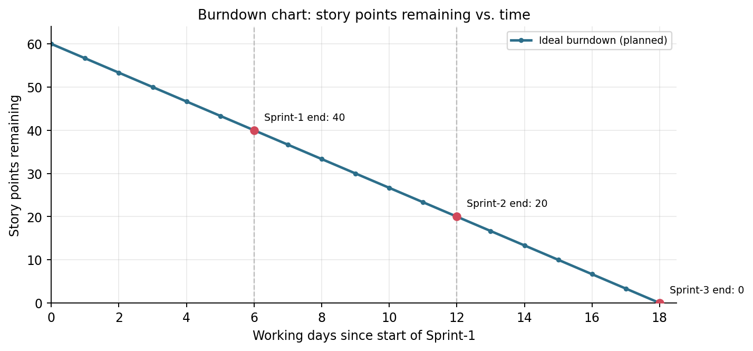
Reference:
https://www.atlassian.com/agile/project-management
https://www.atlassian.com/agile/tutorials/how-to-do-scrum-with-jira-software
https://www.atlassian.com/agile/tutorials/epics
https://www.atlassian.com/agile/tutorials/sprints
https://www.atlassian.com/agile/project-management/estimation
https://www.atlassian.com/agile/tutorials/burndown-charts

